**Lab No.1**

01. Write a C Program to play beep five time.

**Out put:**

#include <stdio.h>

#include <stdlib. Only Beep Sound

int main() {

printf("\a\a\a\a");

return 0;

}

02. What does the following code print?

printf( "\n\n*\n**\n****\n" );

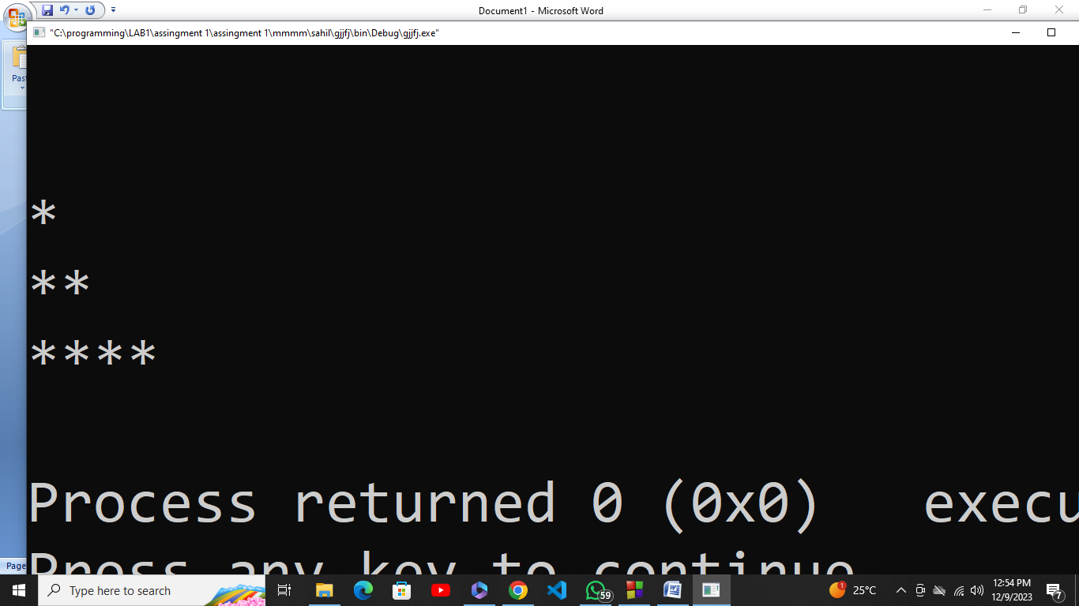

**Out put:**

#include <stdio.h>

#include <stdlib.h>

int main()

{

printf( "\n\n*\n**\n****\n" );

return 0;

}

03. Write a C program to print the following shapes using escape sequences.

#include <stdio.h> **Out put:**

#include <stdlib.h>

int main()

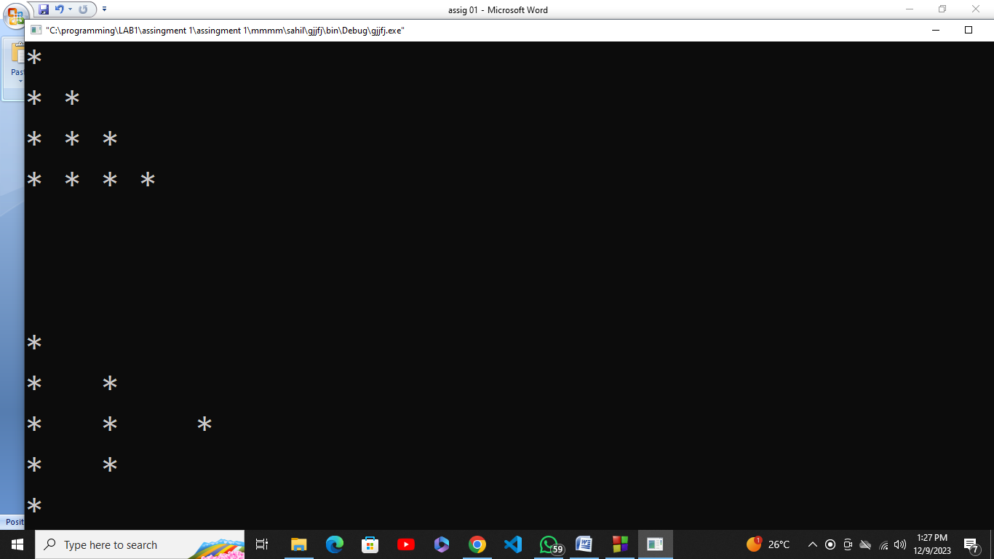

{

printf("* \n");

printf("* * \n");

printf("* * * \n");

printf("* * * * \n");

printf("\n");

printf("\n");

printf("\n");

printf("* \n");

printf("* *\n");

printf("* * *\n");

printf("* *\n");

printf("* \n");

return 0;

}

04. Write a program that prints the following shapes with asterisks.

#include <stdio.h>

#include <stdlib.h> **Out put:**

int main(){

printf("********* *** * *\n");

printf("* * * * *** * *\n");

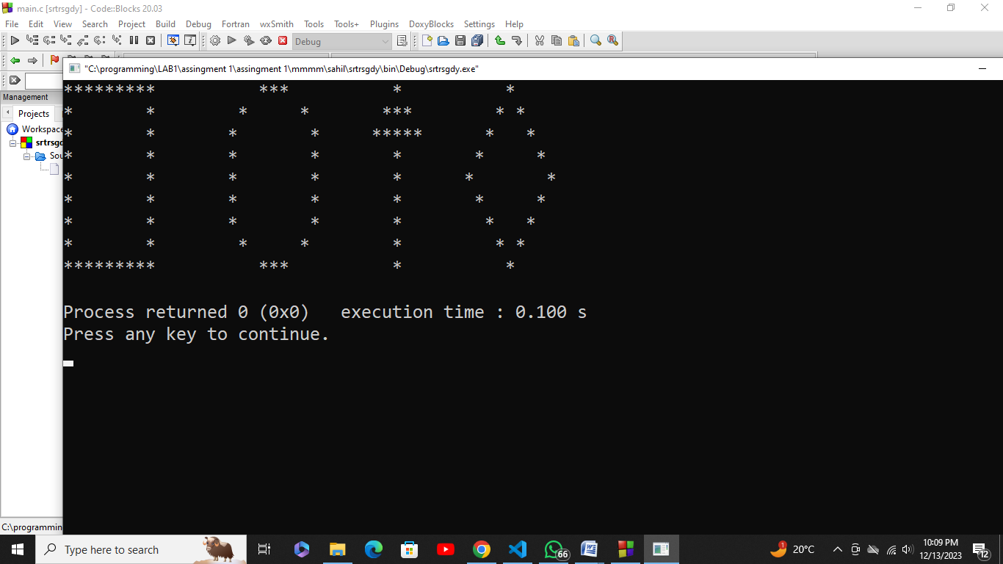

printf("* * * * ***** * *\n");

printf("* * * * * * *\n");

printf("* * * * * * *\n");

printf("* * * * * * *\n");

printf("* * * * * * *\n");

printf("* * * * * * *\n");

printf("********* *** * * \n");

return 0;

}